**Rusada Technical Task Output**

**Step1: Need to create table using below script:**

CREATE TABLE [dbo].[TaskDetails](

[TaskID] [bigint] IDENTITY(1,1) NOT NULL,

[Title] [varchar](100) NULL,

[Description] [varchar](max) NULL,

[CreatedDate] [datetime] NULL,

[ModifiedDate] [datetime] NULL,

[DueDate] [datetime] NULL,

[Schedule] [bit] NULL,

[ScheduleDate] [datetime] NULL,

[Completed] [bit] NULL,

[CompletedDateTime] [datetime] NULL

) ON [PRIMARY] TEXTIMAGE_ON [PRIMARY]

**Step2: Need to execute the below script (This is for Test Data To Check Performance)**

**DECLARE @count INT;**

**DECLARE @StartDate DateTime;**

**DECLARE @Task varchar(100);**

**SET @count = 1;**

**SET @StartDate ='01/01/2000';**

**WHILE @count <= 10000.**

**BEGIN**

**set @Task = 'Task-' + CAST(@count as varchar);**

**set @StartDate = DATEADD(day, 1, @StartDate);**

**INSERT INTO [dbo].[TaskDetails](Title,Description,CreatedDate,DueDate) VALUES(@Task,@Task +' Test Data ', @StartDate,@StartDate)**

**SET @count = @count + 1;**

**END;**

**Step3:Need to Change the Sql Connection settings in app config file and then run the application**

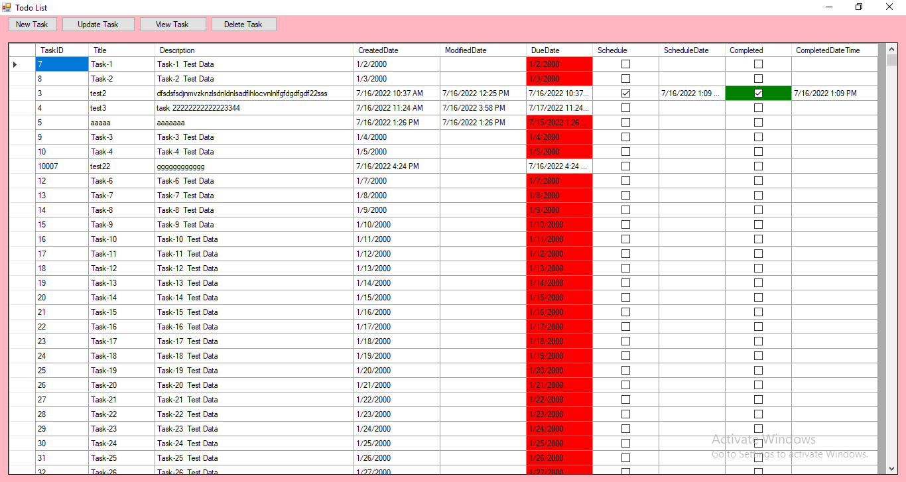

The above form shows Red color indicates Due Date Expired, and green color indicates Completed task.

**Step4: Click New Button to create New Task.**

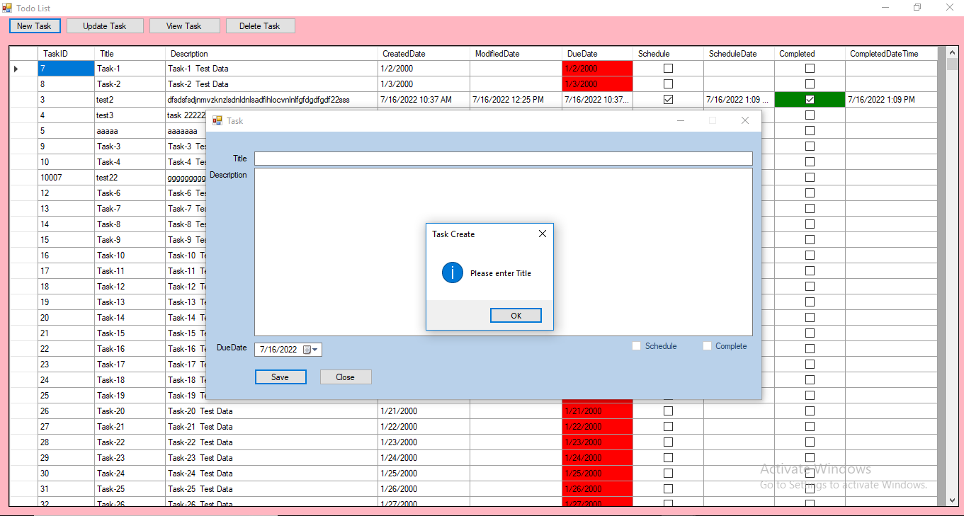

**Step5: Enter Some Title and description and click Save button and while create new record Schedule and Complete flag is disabled, it will enable only on update the task.**

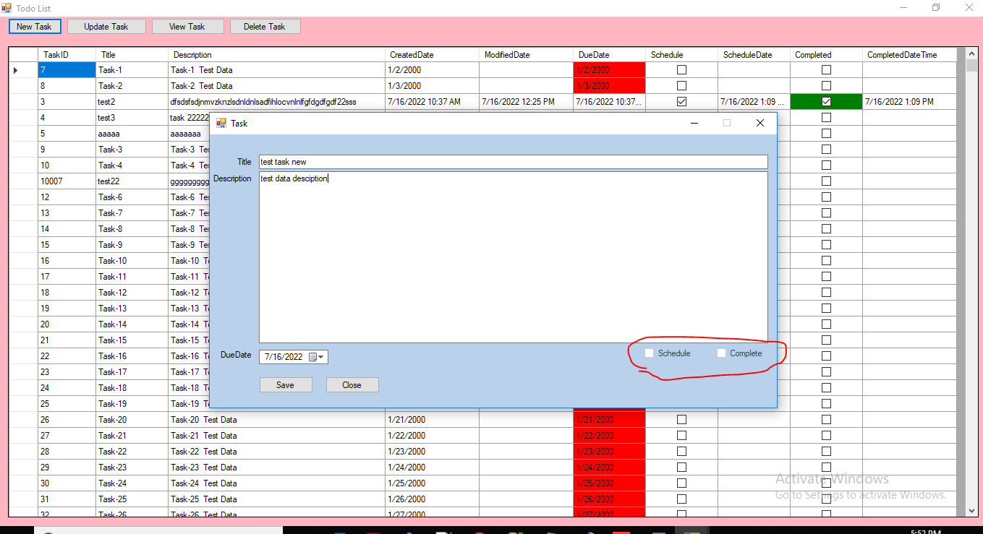

**Step6: Past Due Date Validation**

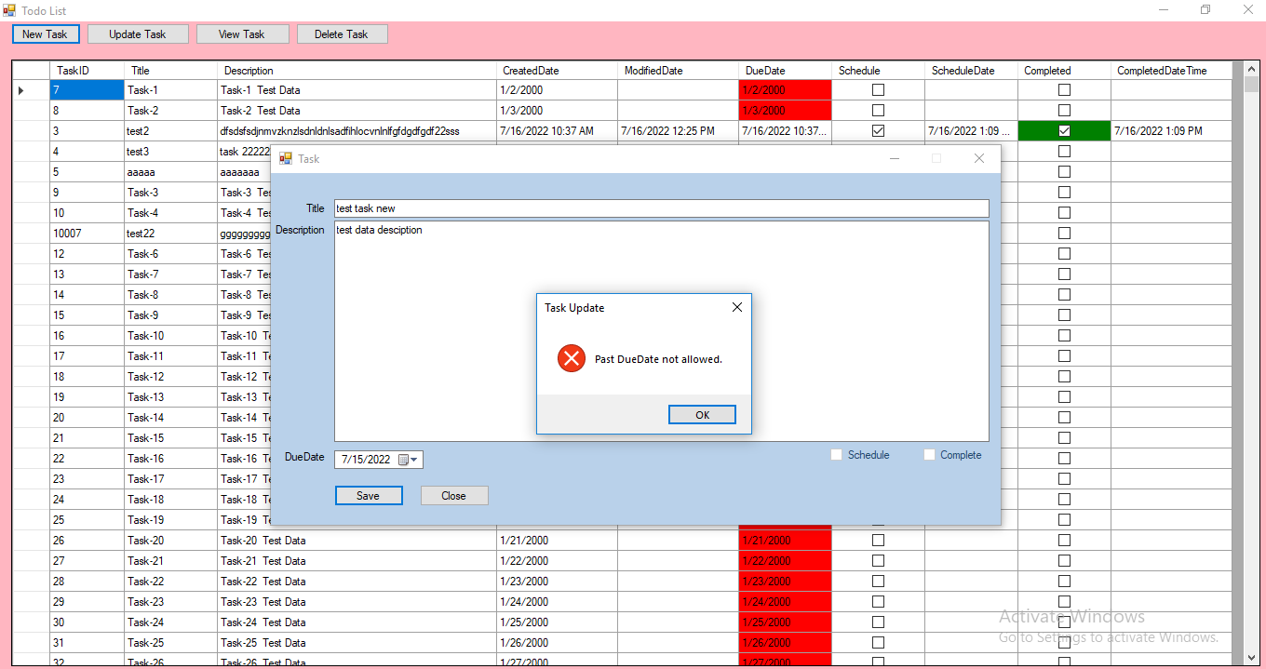

**Step7: Update the task by click Update task button**

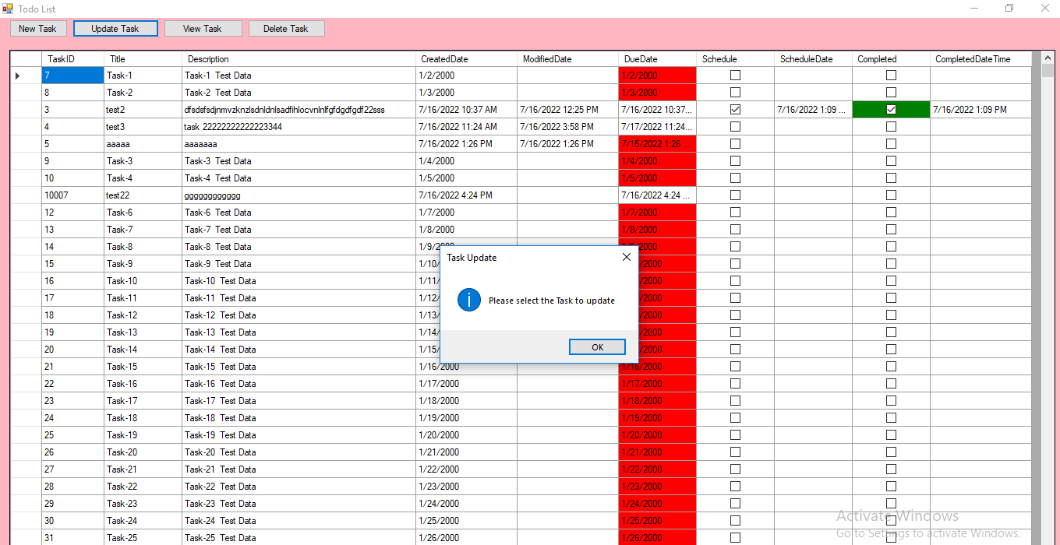

If I try to update task Past due date task, then all the controls is disabled

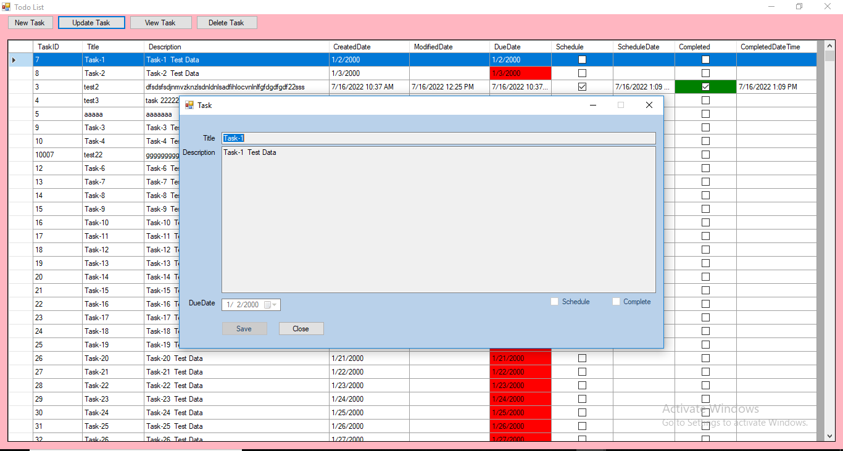

Then I select the task which is not expired due date then it is allow to edit or schedule and complete

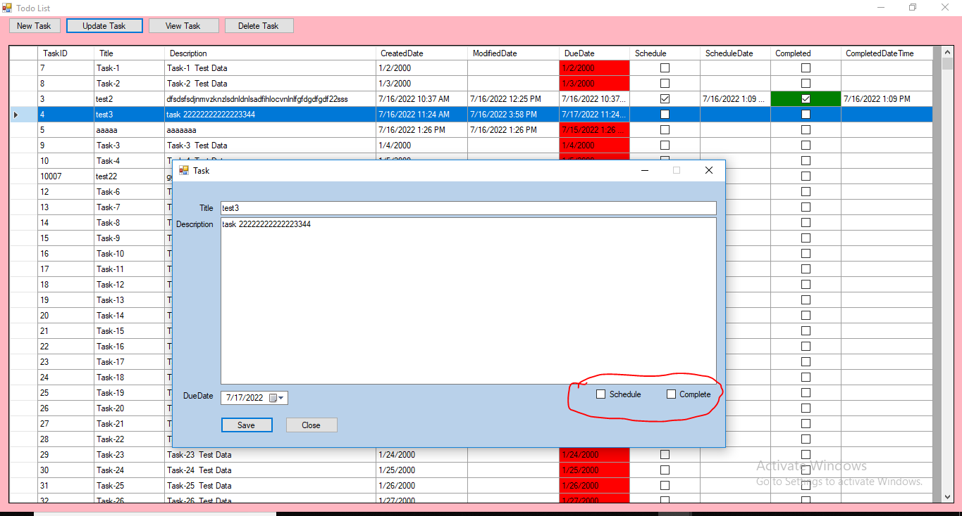

Step8: View mode by click view task button, all the controls are disabled in view mode.

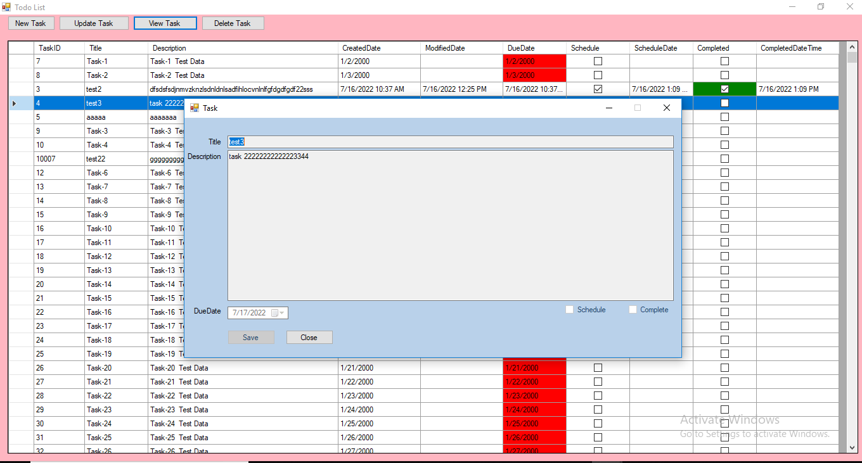

Step9: Delete the task using delete button, it will ask confirmation to delete

